9/9/2026
Call to order: 6:01 pm by Vanessa Dagle

- Attendance: Sonia Alcantar Anguiano, Shirmir Branch, Janet Bryant, Anna Cavinato, Vanessa Dagle, Sandra Fiskum, Jim Floyd, Dave Heldebrant, Matthew Hurlock, Mariefel Olarte, Kristin Omberg, and Cassandra Reese.
- Approval of June and July Meeting Minutes: Cassandra presented the minutes; edits discussed included clarifying event descriptions. Minutes were approved with corrections.
- Treasurer’s Report: Sandra presented July and August financials. July: Savings unchanged at $52,505.46; checking at $11,346.12; expenses included Chemistry Olympiad T-shirt reimbursement, advertising, and Science Cafe supplies. August: Created new budget category for NORM 2028 bid, updated account access, and began compiling records for audit. Savings unchanged; checking at $11,072.94. Receipts included ACS dues and LS Meet Grant. Expenses covered website hosting, grants, poster printing, summer picnic, stamps, newsletter, and support for NORM 2026 Women’s luncheon. Sandra noted missing records for 2025 and discussed efforts to recover them, including digital files and USB drives. Both reports were approved.
- Bank Account Changes: Sandra proposed renaming the Banner Bank checking account to "ACS Richland Section" for clarity and creating a new account for NORM 2028, with associated debit cards and $500 seed money. The group discussed compliance with ACS requirements and agreed these changes would better reflect local section identity. Motions for both actions were approved, with Sandra, Janet, and Kristin given access to the new NORM 2028 account.
- NORM 2028 Planning: Janet updated on NORM 2028 organizing committee progress, including Sandy as Treasurer. The team will run a logo and theme contest among members, focusing on topics like analytical chemistry, energy, AI, and fusion. The contest aims to quickly gather input for promotional materials and save-the-date communications. Janet requested permission to proceed, which was granted.
- WCC Science Café Budget: Shirmir discussed hosting Alyssa Park from UCLA for a Science Cafe dinner at Bud’s Broiler. Venue costs exceed available WCC funds. Vanessa proposed reallocating unused funds from Environmental and Safety Committees to support the event, increasing the budget to $1,200, later $1,500 with additional speaker funds. The committee debated how to handle attendee charges, ultimately agreeing to limit free attendance to the first 10–15 ACS members who RSVP, with subsequent ACS members paying $20–$25 and non-members or guests automatically paying $25. This approach was designed to balance event costs and encourage early RSVPs, while ensuring that ACS members receive priority access. The group also discussed cost-sharing options and confirmed that the revised budget would allow the event to proceed as planned.
- Teaching Funding Awards: Vanessa presented two requests: Horse Heaven (Title 1, Kennewick) for $500 in lab supplies, and Leona Libby Middle School for $1,200–$2,800 in equipment. The group agreed to use remaining I&B grant funds ($1,000) and K12 outreach funds ($500) to support Libby, and $500 for Horse Heaven from the teacher award category. Anna suggested maximizing use of available outreach funds. The motion was amended and approved. Sonia suggested future ACS grant applications for teachers.
- I&B Grant Proposal: Anna proposed a mentoring and professional development event for Women’s History Month or Black History Month, featuring a panel of women scientists at various career stages. The event would include interactive discussions and networking, with food limited to 20% of the grant budget. Anna requested help identifying venues, speakers, and advertising strategies, and will draft a proposal for review.
- ACS National Meeting and Chem Luminary Awards: Dave reported ACS membership statistics, pilot lifetime membership, and meeting attendance. The new ACS logo was discussed, with mixed reactions. Anna noted the section was a finalist for two Chem Luminary awards but did not win. Janet shared that the awards process is being overhauled and encouraged nominations for local section Chemist of the Year.
- Annual Social Dinner: Kristin confirmed the Richland Community Center is booked for November 6. Pacific Pasta will cater again. New insurance forms require clarification on minors; group agreed parents are responsible for their children at the event. Entertainment will be chemistry trivia instead of a speaker. Student poster presentations will continue, with Janet providing ACS giveaways.
- Upcoming Elections: Sonia announced Jason as a candidate for Treasurer, with bio submitted for the newsletter. The group discussed election timing, aiming for results before the annual social and reporting to ACS by December. Additional candidates for Chair-Elect are sought.
- Committee Reports:
  - Awards – Janet noted the ACS National Award winners are posted and encouraged nominations for local Chemist of the Year.
  - Bylaws – Janet and Shirmir confirmed the revised bylaws draft is pending review and submission to ACS C&B.
  - Diversity and Inclusion – No update.
  - Education – No update.
  - Government Affairs – No update.
  - Membership – Sandra reported three new members welcomed, five terminations, one transfer out, and welcome letters sent.
  - Nominations – Sonia is seeking candidates for Treasurer and Chair-Elect; bios and photos requested.
  - Programs – Kristin is planning the annual social, confirmed venue and date, and is coordinating catering and entertainment.
  - Public Relations / Newsletter – No update.
  - Women Chemists – Shirmir discussed the Science Café event and received additional funding; no additional update.
  - Younger Chemists – Jim and Matthew reported no new YCC events before the national meeting; they plan to schedule the next activity for the fall.
  - Environmental – No update; position remains vacant.
  - Safety – No update.
  - Historian – No update; position remains vacant.
- Round Table –
Vanessa adjourns the meeting at 7:08 pm.

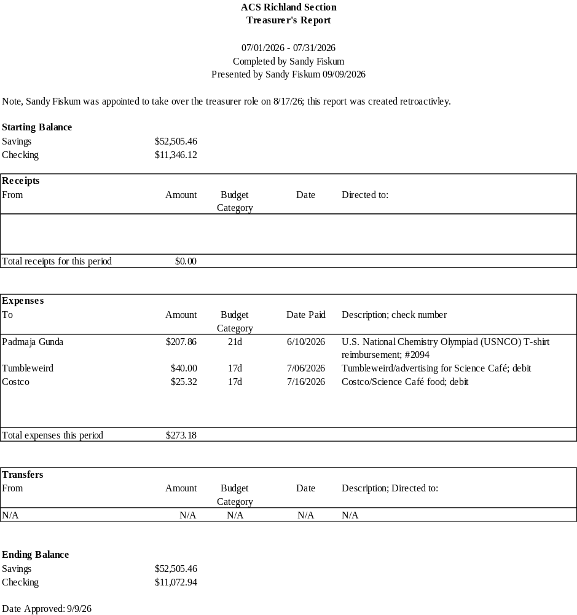

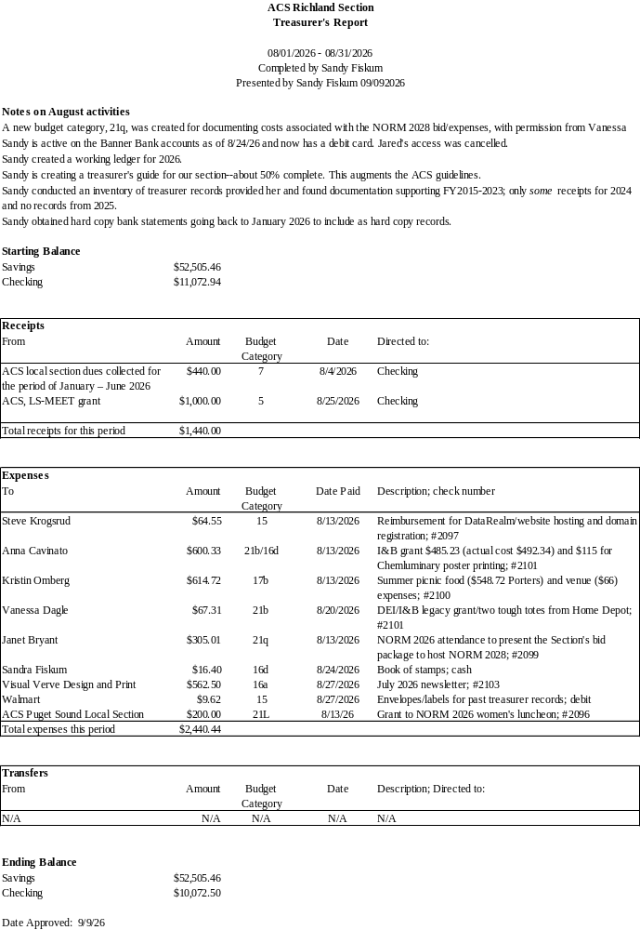
Upcoming Events

Annual Social (November 6th)

