8/12/2026
Call to order: 6:01 pm by Vanessa Dagle

- Attendance: Janet Bryant, Anna Cavinato, Vanessa Dagle, Sandra Fiskum, Jim Floyd, Colby Heideman, Matthew Hurlock, Steve Krogsrud, Kristin Omberg, and Cassandra Reese.
- Approval of June and July Meeting Minutes: The Executive Committee reviewed the June and July minutes prepared by Cassandra. Vanessa noted that the June minutes incorrectly referred to “Alice Smith” and clarified that this should be LS‑MEET. Cassandra agreed to make the correction based on the chat record. Sandra moved to approve the June minutes as amended; Kristin seconded, and the motion carried. Anna moved to approve the July minutes; Sandra and Kristin seconded, and the motion carried. Cassandra will upload the corrected June and July minutes to the website.
- Treasurer Transition and Audit/Record Issues: Vanessa summarized ongoing concerns regarding the execution of Treasurer duties, including reimbursements outstanding since March and an audit incomplete since January. She has scheduled a meeting with the current Treasurer to retrieve the checkbook and financial documents so reimbursements and audit work can resume. Vanessa apologized to affected members for the delays.
The Executive Committee discussed next steps consistent with bylaws and good governance practices. The Chair will request a written resignation from the current Treasurer and will provide a prepared resignation letter for signature to ensure clarity and documentation. After resignation, the EC will conduct a formal vote—either electronically or in a brief additional meeting—to appoint Sandra Fiskum as interim Treasurer through December 31, 2026. Updated minutes will be provided to Banner Bank to support the required signature‑authority change.
The EC also discussed challenges with missing digital records and receipts. Some documentation exists in Word files but not in spreadsheet form. The committee agreed to reconstruct available records and document any gaps for the next audit cycle.
- Event Updates: Summer Picnic, Science Café, and Fall Social: Kristin reported that the summer picnic, catered by Porter’s, had 26 attendees and was well received, with no major logistical issues. She thanked those who attended and helped.
Kristin also updated the EC on the fall social. A tentative date of November 6 has been selected, and she is coordinating with Dave and ACS President Rigoberto Hernandez regarding his possible participation. Kristin noted that she is now a licensed alcohol server in Washington State and can serve in that capacity at the social, subject to the liability considerations previously discussed.
Matthew reviewed the mid‑July Science Café at the Richland Public Library. In‑person attendance was strong, and the Q&A was active, though there were some technical challenges with hybrid participation. Matthew will complete an event report (including attendance, highlights, and lessons learned) for the annual summary and will provide photos. Vanessa asked him to also submit his presentation slides so they can be posted on the website as supplemental material. Sandra and Colby suggested scheduling future Science Cafés during university terms and using the new hybrid equipment once purchased.
- LS-MEET Grant Award: Jim announced that the section received $1,000 (half of the requested amount) from the LS‑MEET grant and thanked Matthew and Anna for their help on the proposal. The funds will be used to purchase cameras and microphones to support hybrid meetings and events. Jim explained that the goal is to make setup easier and to improve audio/video quality for remote participants at Science Cafés, business meetings, and outreach events.
- National Meeting Preparations and Poster Presentation: Anna reported that the ChemLuminary‑related poster has been printed and shipped to the ACS national meeting in Chicago and will be displayed there. Janet requested a copy for section records; Anna will send a PDF to Janet and Vanessa. Janet also invited interested members to an awards reception hosted by the Division of Business Development and Management on August 25 at the London House Hilton Hotel, noting that email reservations are required.
- ACS Pop‑Up Store and Branding Transition: Vanessa reported that the section received a kit of ACS merchandise through the ACS pop‑up store, including a banner, tablecloth, pencils, and stickers. She thanked the colleague who alerted her to the opportunity. Anna reminded the committee that ACS is transitioning to a new logo and that older logo materials will eventually need to be replaced. She encouraged Colby and others to plan for updated tablecloths and outreach materials over time.
Janet and Anna noted that ACS provides a branding toolkit and guidance for local sections. Kristin confirmed that updated logos and branding files are available online and offered to share the link with the EC. Anna mentioned that ACS offers branding training sessions for local sections and suggested that Richland consider participating as they update their materials.
- Bylaws Revision and Election Planning: Janet summarized the status of the bylaws revision. The EC previously approved changes clarifying the duties of the immediate past chair and establishing staggered two‑year terms for Secretary and Treasurer. Janet is finalizing the draft and will send it to the ACS Constitution & Bylaws (C&B) staff liaison for review. Under the new schedule, the Treasurer position will be on the ballot this year and the Secretary position next year, maintaining a staggered cycle.
Vanessa confirmed that, after C&B review, the revised bylaws will be sent to the full membership for a vote, likely using a Google Form. She confirmed with Cassandra that she is willing to serve one additional year as Secretary under the new structure; Cassandra agreed.
- Committee Reports:
  - Awards – No update.
  - Bylaws – No additional update beyond the planned submission of the revised bylaws to the C&B staff liaison noted above.
  - Diversity and Inclusion – No update.
  - Education – No update.
  - Government Affairs – No update.
  - Membership – Sandra reported that welcome letters were sent to ten new members. She noted two transfers, five terminations, and one reinstatement. She also reported that ACS notified the section of the passing of Ron Walters, and she and Janet briefly discussed the roster status of Cal Delegard to ensure records are accurate.
  - Nominations – Sandra reiterated the need to begin identifying candidates and preparing biographies for the fall election.
  - Programs – Kristin continues planning for the fall social and will confirm the November 6 date with Dave and ACS President Rigoberto Hernandez.
  - Public Relations / Newsletter – Steve reported no new newsletter content at this time but will coordinate with Vanessa to ensure website payment is current and will provide the mailing address for any checks.
  - Women Chemists – No update this month.
  - Younger Chemists – Jim and Matthew reported no new YCC events before the national meeting; they plan to schedule the next activity for the fall.
  - Environmental – No update; position remains vacant.
  - Safety – No update.
  - Historian – No update; position remains vacant.
- Round Table –
Vanessa adjourns the meeting at 7:08 pm.

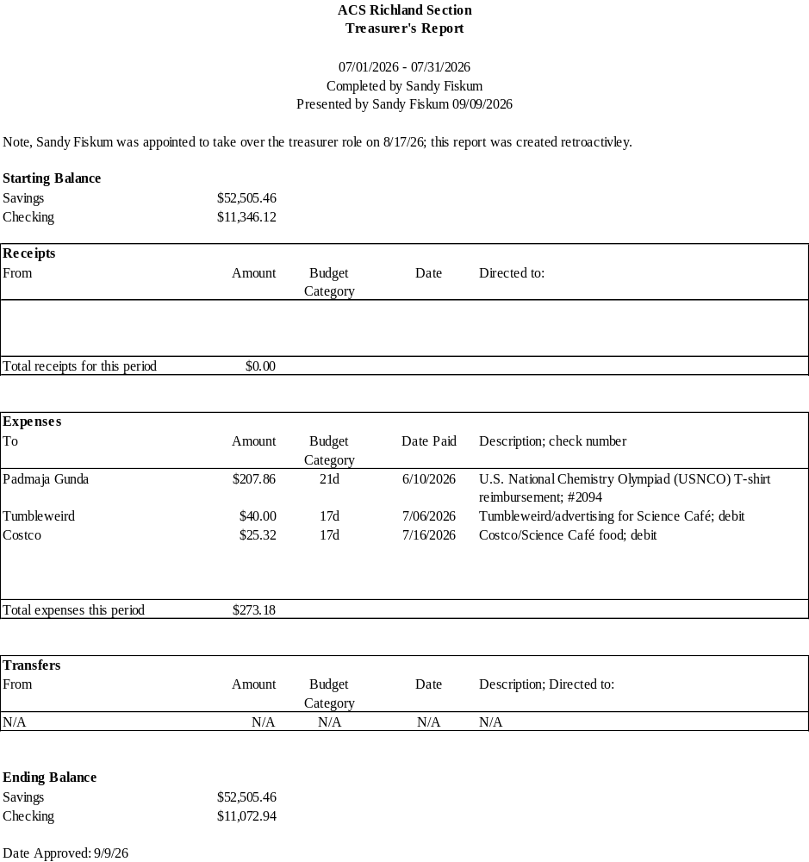

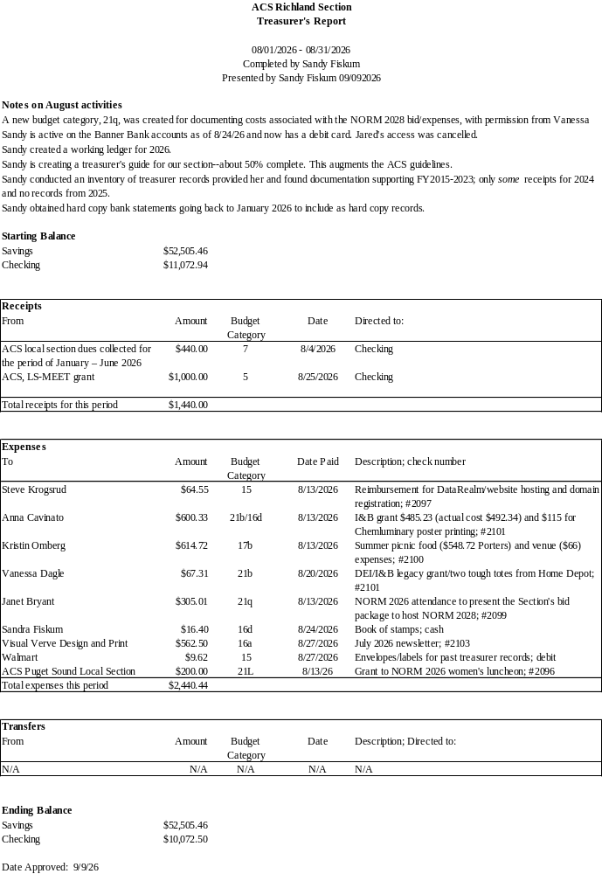
Upcoming Events

Annual Social (November 6th)

