1/14/2026
Call to order: 6:05 pm by Vanessa

- Attendance: Sonia Alcantar Anguiano, Shirmir Branch, Janet Bryant, Anna Cavinato, Vanessa Dagle, Sandy Fiskum, Jim Floyd, David Heldebrant, Matthew Hurlock, Steve Krogsrud, and Cassandra Reese.
- Approve December 2025 Meeting Minutes: Cassandra presents the December 2025 executive committee (EC) meeting minutes. Janet Bryant moved to approve the December EC minutes, and Anna Cavinato seconded the motion. The December EC minutes were approved unanimously. Cassandra has for action to upload the EC minutes to the website.
- Mid-Columbia Science Fair Funding Request: Vanessa relayed a request from Jeff Brown for $700 to support the Mid-Columbia Science Fair. Last year, the section budgeted $600, with an additional $100 coming from a personal donation. Dave Heldebrant volunteered to donate $100 again this year so that the section’s contribution would remain at $600. The EC agreed that finalizing the commitment should wait until the 2026 budget is approved. The science fair will be held in March.
- ACS Leadership Institute Presentation: Dave provided an overview of the upcoming ACS Leadership Institute, a weekend onboarding event for section, division, and committee leaders. Dave will give a 20-minute presentation highlighting the Richland Section’s successes, including student chapter awards, ChemLuminary recognition, and the role of mentorship and succession planning in sustaining section activity. Dave will share the presentation content with the EC at a future meeting.
- Annual Report Preparation and Financial Review: Sonia reported that the annual report is due February 15. She requested completed event forms from all event leads and three section goals from Vanessa and Kristen. Sonia also asked for input on potential ChemLuminary award nominations and relevant supporting information. Shirmir raised the need for the required annual review of the financial books. Janet noted that the review is required by the bylaws and must be completed by March 31; it does not need to be finished by the annual report deadline. Vanessa will contact Jared to ensure he arranges for a financial report auditing with a past treasurer (e.g., Philip, Deepika, or Sandy), to be completed by March 31.
- Robotics Team Funding Request: Sonia presented a letter from a newly formed robotics team requesting funding to support competition expenses in the range of $3,000–$7,000. The team has recently advanced and faces increased financial needs. The EC discussed potential future collaborations and the possibility of supporting the team through grants and other mechanisms. In keeping with section practice, members recommended that the students present their request directly to the EC. Janet also emphasized the need for treasurer input and for any support to be considered within the context of the 2026 budget.
- Upcoming STEM Outreach Events: Shirmir announced three upcoming STEM outreach events and requested volunteers and leads: Introduce a Girl to Engineering Day – February 26, Kids Engineering Day – March 14, REACH Museum Earth Day Event – April 18 (registration closes February 1st). Volunteers are needed to serve as points of contact and to help plan and staff activities. Sonia and Shirmir discussed reusing leftover materials from previous events and developing new activities, including chemistry-of-spices ideas. Anna suggested integrating the ACS 150th anniversary theme into outreach programming throughout the year; she and Dave will gather additional ideas at the Leadership Institute.
- Budget Approval Process and Changes: Vanessa led a discussion on the pending 2026 budget. The EC agreed that an email vote would be efficient, with the understanding that a meeting would be scheduled if substantial discussion is needed. Sandra recommended waiting until approximately February 1 to finalize the vote, unless urgent bills arise. Sonia summarized major changes: no LS-Meet or IPG grant applications this cycle, resulting in lower expected grant income and related expenses, and a reduction in the Women Chemists Committee budget to better match anticipated costs. Members were encouraged to review the budget carefully.
- Formation of Bylaws Committee: In response to recent ACS governance changes, Janet proposed forming an ad hoc Bylaws Committee. No budget required. She volunteered to chair the committee; Matt, Shirmir, and Anna volunteered to serve. Sandra recommended including younger members to support leadership development. Janet noted that, per section practice, Shirmir confirmed that the Bylaws Committee will be listed under “appointed committees” on the section website.
- Committee Reports:
  - Awards – Janet agreed to help Sonia – the past-chair – with this committee.
  - Diversity and Inclusion – Anna reported ongoing coordination with Colby, Bree, and Mary to organize outreach and a talk. She recommended updating local committee titles to align with ACS national language emphasizing inclusion and belonging.
  - Education – No update.
  - Government affair – No update.
  - Membership – Sandra reported on membership changes, including four new members, 13 terminations, and 1 reinstatement. She also discussed roster access issues that she and Anna are working to address.
  - Nominations – No update
  - Programs – No update.
  - Public relations – Shirmir is working with Matt Monroe to update the website. She requested draft “incoming/outgoing officer” letters or content for LinkedIn and other social media posts.
  - Women Chemists – Shirmir is targeting a women’s brunch for Women’s History Month. She is contacting potential venues and seeking a keynote speaker. Any Saturday in March that does not conflict with other section or community events is under consideration. Vanessa and Anna shared ideas for speakers and dates. Volunteers are welcome.
  - Young Chemist – Matthew and Jim are planning activities focused on career development, including resume workshops and mock interviews. They are considering virtual or hybrid formats to reach members at a distance. Janet offered to connect them with an international member who could assist with programming.
  - Environmental – No update as the position is vacant.
  - Safety – No update.
  - Historian – No update as the position is vacant.
- Round Table –
Vanessa adjourns the meeting at 7:00 pm.

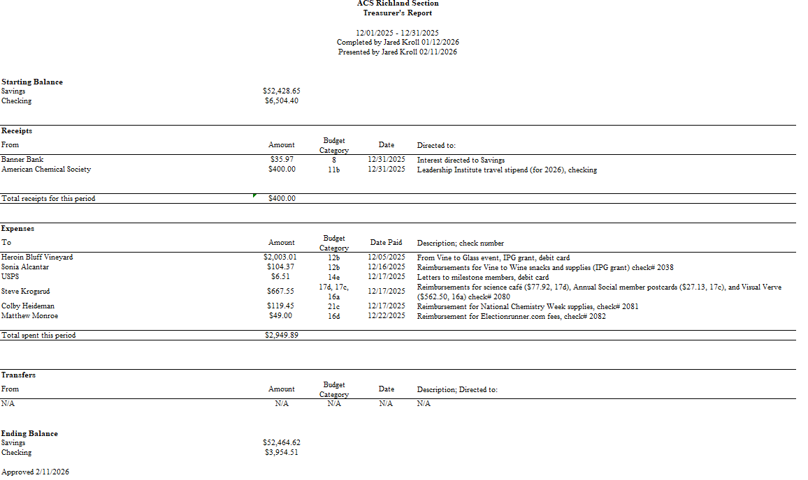

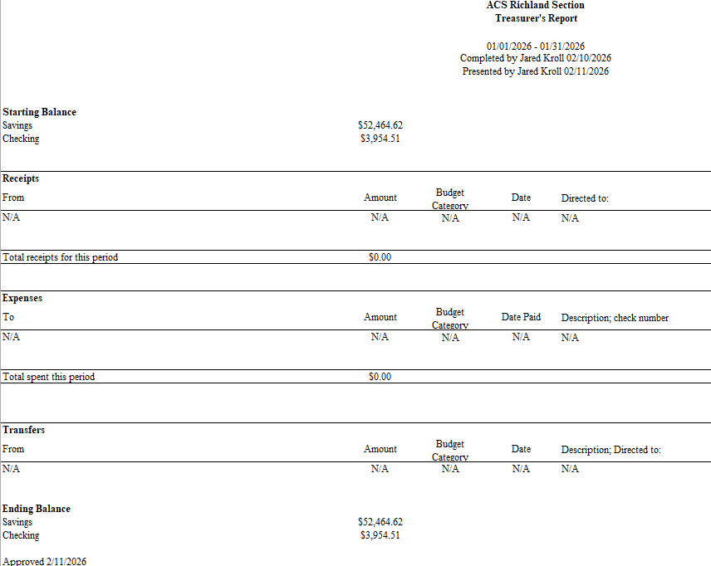

Upcoming Events

Introduce a Girl to Engineering Day – February 26 (4-6pm) at Richland Public Library

Kids Engineering Day – March 14 (10 am – 1 pm) at Edwin Markham Elementary

REACH Museum Earth Day Event – April 18 (12-4 pm)

