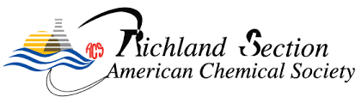

ACS Richland Section K-12 Student Travel Award

- Please email the required materials to the ACS Richland Section secretary (contact info is available at https://acsrichland.org/about/leadership/).
- Funding requests of up to $300 may be considered to support transportation and lodging for a K–12 student participating in a chemistry Olympiad, meeting or conference.
- Applications must be received at least eight weeks prior to the event for which support is requested.
- Each student is eligible to receive this award only once per year.
- Award recipients are asked to present a poster of their work at the ACS Richland Section annual social event.

Name
Grade
Current school
Email address
Name, Date & location of the meeting you will attend
Is it your first time presenting your work at a chemistry Olympiad/ meeting/ conference | Select one:  Yes No
If you are selected for this award, are you willing to present your work at our annual social event in November? | Select one:  Yes No

