12/11/2024

Call to order: 6:05 pm

**Attendance**: Sonia Alcantar Anguiano, Shirmir Branch, Anna Cavinato, Emily Diaz, Colby Heideman, Jared Kroll, Mariefel Olarte.

1. **Approve November 2024 Meeting Minutes** – Shirmir presents the November 2024 executive committee (EC) meeting minutes on behalf of Vanessa. Due to the lack of quorum, approval of the EC minutes was conducted on-line via email. The EC minutes was approved December 21st with 6 in favor and 0 not in favor.
2. **Approve November 2024 Treasurer’s Report** – Shirmir presents the November 2024 treasurer’s report on behalf of Padmaja. Starting balance is $50,258.10 in savings account and $15,883.74 in checking account. The total of receipts for November 2024 is equal to $818.00. The total of the expenses for November 2024 is equal to $6,167.29 as detailed in the attached report. Ending balance is $50,258.10 in savings and $10,534.45 in checking. Due to the lack of quorum, approval of the treasurer report was conducted on-line via email. The treasurer report was approved January 2nd with 6 in favor and 0 not in favor.
3. **Budget proposal for 2025** – Shirmir shares the proposed 2025 budget. Anna recommends adding a line in the budget for an in-person meeting to conduct a mini-retreat for reviewing the session goals and accomplishments in preparation for a larger upcoming strategic plan meeting. Shirmir will add $100.00 to the meals for this event. Mariefel suggests using a classroom located in WSU BSEL for this event. Shirmir will send an email with the proposed draft for on-line voting.
4. **2025 Elections Results for the LS Executive Committee** – Shirmir shares the results of the elections. A total of 71 people voted for this election which represents an increase compared to last year. Emily was elected secretary, Jared was elected treasurer and Vanessa was elected chair elect. Jared will need to fill up the administrative form and the financial form from ACS community connection website. Emily will need to submit the letter to Banner Bank to update the authorized signature to the bank account.
5. **Strategic Plan** – Anna presents a summary of the 2019 Strategic Plan. The three following goals had been identified: Goal 1: Communicate the wonder of chemistry to the students and the community, Goal 2: provide members with opportunities for exchange of knowledge, networking, professional development and recognition, Goal 3: empower and engage members and member communities in the Richland local section) and for each goal there was a strategy. Anna indicates that some of the goals have been achieved and the strategic plan should be revised sometimes in 2025. Anna offers to guide the discussion since she has participated to many strategic plans.
6. **ACS Leadership Institute: 31 January- 2 February** **2025** – Both Jared and Emily will participate to the ACS Leadership Institute that will be held in Texas. Sonia indicates that the expenses should be part of the 2025 budget. Both Jared and Emily agree to get a refund in January 2025 as opposed to December 2024.
7. **2025 Committee Chairs** –Anna will continue to be the chair for Diversity and Inclusion, Colby will continue to be the chair for Education, Jared will continue to be the chair for Safety, Shirmir will be the chair for Awards, Vanessa will be the chair for Program Committee. Shirmir will reach out to current committee chairs to find out if they want to continue in their role. Shirmir indicates that there are several committee sections for which a chair is needed, and an open call will be added to the January Newsletter.
8. **Annual Report** – Shirmir will need to submit the 2024 annual report February 15th. The report will include a summary of all the events that were conducted in 2024. Anyone who organized an event should share information with Shirmir so that she can add them to the report. Anna suggests sending the template to those who organized events to help write the report.
9. **Students Chapter –**Shirmir will reach out to Padmaja to verify her willingness to hold the Science Olympiad in January.
10. **Committee Reports** –
    1. Awards – no update.
    2. Diversity and Inclusion –Anna shares that the section was awarded the DEI grant for which Mickey had put a proposal for conducting an event with the Umatilla and Yakima Indigenous tribes. Anyone interested in volunteering should reach out to Mickey.
    3. Education – Colby put together a template for Student Awards. This template will be added to the website.
    4. Government affair – no update.
    5. Membership – Anna shares that there are 4 new members.
    6. Nominations – see bullet 4.
    7. Programs – no update.
    8. Public relations – no update.
    9. Women Chemists – no update.
    10. Environmental – no update.
    11. Safety – no update.
    12. Historian – no update.
11. **Round Table** –

Shirmir adjourns the December 2024 executive committee meeting at 7:00 pm.

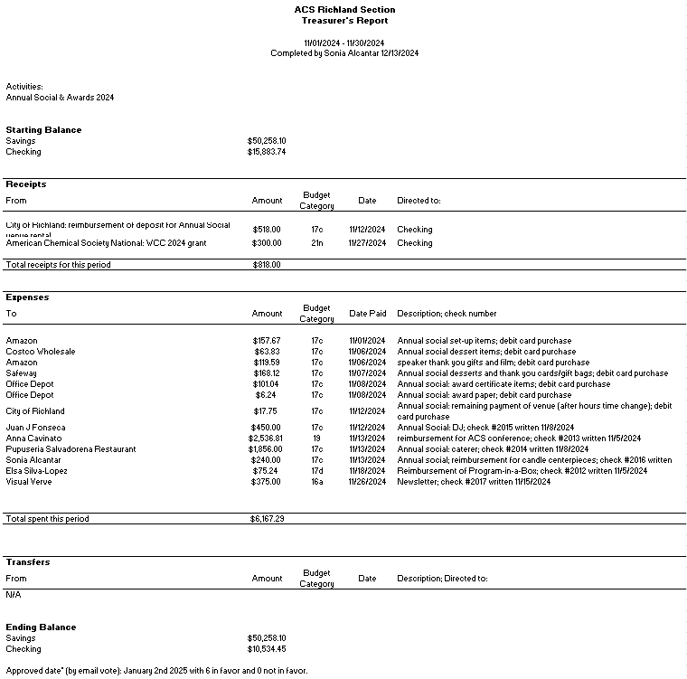

**Upcoming events**

* February 22nd, 2025: Country Mercantile Chocolate Factory tour – The chemistry of Chocolate.
* March 8th, 2025: Visit of LIGO – Laser Interferometer Gravitational-Wave Observatory.
* March 2025: Visit of Wheat Head Brewing – Chemistry behind the making of Beer