11/11/2024
Call to order: 6:02 pm

Attendance: Sonia Alcantar Anguiano, Shirmir Branch, Janet Bryant, Vanessa Dagle, Emily Diaz, Padmaja Gunda, Colby Heideman, David (Dave) Heldebrant, Jared Kroll.

- Approve October 2024 Meeting Minutes – Vanessa presents the October 2024 executive committee (EC) meeting minutes. Dave moves to approve the October 2024 EC meeting minutes. Padmaja seconds the motion. Motion passes unanimously. Vanessa has the action to upload the October EC meeting minutes to the Local Section (LS) website.
- Approve October 2024 Treasurer’s Report – Padmaja presents the October 2024 treasurer’s report. Starting balance is $50,258.10 in savings account and $14,531.24 in checking account. The total of receipts for October 2024 is equal to $2,325.00. The total of the expenses for October 2024 is equal to $972.50 as detailed in the attached report. Ending balance is $50,258.10 in savings and $15,883.74 in checking. Sonia moves to approve the October 2024 treasurer’s report. Dave seconds the motion.
- Visit of Coyote Canyon Mammoth site: 12 October 2024 – Vanessa shares some slides summarizing the visit at Coyote Mammoth site that was organized as part of the LS-MEET grant. The event was well attended. A total of 28 people registered for the event and 25 people were in attendance. The event included a slide show of the ice-age, a tour of the laboratory and a visit to the dig site.
- Safety Science Café: 22 October 2024 – Jared organized a hybrid Science Café October 22nd at the Richland Public Library. Dr Frankie Woodblack gave a lecture about “Perceptions of Risks”. Jared indicates that the lecture was well received by the attendees. A total of 5 people attended in person and 4 people attended via Teams.
- National Chemistry week (NCW): October 2024 – Colby indicates that EOU organized the Investigators in Science event for the NCW. About 100 students from middle school attended the event and learned about fluorescence by analyzing fish kidneys that had been marked with a fluorescent dye that attached bacteria in different levels of infection. EOU received very positive feedback from this event. EOU also organized the ACS program in the box that was attended by 15 students who found the trivia very entertaining. Padmaja indicates that CBC also held the ACS program in the box event. There was a total of 17 participants who enjoyed the trivia. Participants recommended to advertise the event several weeks prior to its date to allow more CBC students to make plans to attend.
- Annual Social Event: 8 November 2024 – Both Shirmir and Sonia share that the annual social event went very well. Sonia thanks everyone who helped. Sonia indicates that WA state changed guidelines for renting venues and WA state needed to verify that the Richland local section is a non-profit organization. Sonia received a letter from ACS national to confirm that the local section is non-profit, and it will be uploaded to the website for it to be used for future events.
- Strategic Plan – Shirmir received an inquiry from Paul Brandt who is part of the ACS Committee on Public Relations and Communications to know how much progress the section has made with its goals from the 2019 Strategic Plan. Shirmir indicates that most of the goals from the 2019 Strategic Plan were achieved since the website and the Newsletter were revamped and a LinkedIn page was created. Shirmir indicates that we should share the 2019 Strategic Plan with the entire section by creating a page on the website.
- Chemistry Olympiad – Shirmir shares that she received an email regarding the Chemistry Olympiad and that few changes are coming. The major change is that the local examination can be made hybrid. Padmaja shares that she registered the Richland local section. She made a flyer, and she is distributing it with high schools in Richland. Shirmir suggests advertising the event on the local section website. Dave will contact David Gotthold to see if the Mid-Columbia Science Fair organizers can share with the teachers. Padmaja is asking if someone else would like to organize the next Chemistry Olympiad event.
- 2025 Elections for the LS Executive Committee – Shirmir indicates that there are only few days left to vote. Three people (Emily, Jared, and Vanessa) submitted their candidature for 2025. Matt Monroe will send the results and Vanessa will need to upload the results on the ACS national website by December 1st.
- 2025 Budget Planning – Shirmir will organize a meeting early December to discuss next years’ budget. Anyone interested in attending this meeting should let her know. Padmaja is requesting $500.00 for the National Chemistry Olympiad.
- Students Chapter – Padmaja indicates that there is no event planned for this quarter. At EOU, several events will be held in this quarter. EOU will be doing an activity with a daycare program, and it will participate in a Festival of Trees event. Shirmir indicates that the Walla Walla Students Chapter and the Yakima Valley Students chapter are active and perhaps we should help them get involved with the local section. Colby volunteered to reach out to them.
- Committee Reports –
  - Awards – no update.
  - Diversity and Inclusion – Mickey and Shirmir have been in contact with John Cox and applied for a DEI grant from ACS. Shirmir indicates that the section is due for a check by November 18th.
  - Education – see bullets 5 and 11.
  - Government affair – no update.
  - Membership – no update.
  - Nominations – no update.
  - Programs – no update.
  - Public relations – no update.
  - Women Chemists – Mickey submitted a grant proposal for the WCC event that was held in March.
  - Environmental – no update.
  - Safety – no update.
  - Historian – no update.
- Round Table –
Shirmir adjourns the November 2024 executive committee meeting at 6:56 pm.

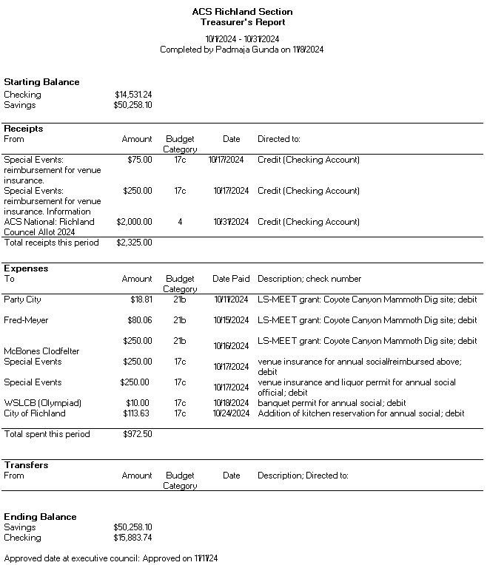

Upcoming events

- February 22nd, 2025: Country Mercantile Chocolate Factory tour – The chemistry of Chocolate.

- March 8th, 2025: Visit of LIGO – Laser Interferometer Gravitational-Wave Observatory.
- March 2025: Visit of Wheat Head Brewing – Chemistry behind the making of Beer

