9/11/2024
Call to order: 6:07 pm

Attendance: Sonia Alcantar Anguiano, Anna Cavinato, Vanessa Dagle, Sandra (Sandy) Fiskum, Padmaja Gunda, Jared Kroll, Mariefel Olarte.

- Approve August 2024 Meeting Minutes – Vanessa presents the August 2024 executive committee (EC) meeting minutes. Due to the lack of quorum, approval of the EC minutes was conducted on-line via email. The EC minutes was approved October 4th with 8 in favor and 0 not in favor.
- Approve August 2024 Treasurer’s Report –Padmaja presents the August 2024 treasurer’s report. Starting balance is $50,220.22 in savings account and $13,146.61 in checking account. The total of receipts for August 2024 is equal to $2,415.00. The total of the expenses for August 2024 is equal to $543.37 as detailed in the attached report. Ending balance is $50,220.22 in savings and $15,018.24 in checking. Due to the lack of quorum, approval of the treasurer report was conducted on-line via email. The treasurer report was approved October 4th with 8 in favor and 0 not in favor.
- Summer Social Picnic: 24 August 2024 – Sonia indicates that the picnic went well, and a survey was sent afterward to receive participants’ feedback. Few suggestions were to start the event with an activity that would allow people to get introduced to each other and to have the food ready before the event start.
- ACS Meeting: 18-22 August 2024 – Anna indicates that the ACS fall meeting was very well attended. She participated to the counselors meeting on August 21st. During this meeting the petition to add new counselors from outside of the United States was passed. The local section won one ChemLuminary Award for “Outstanding NCW event for a special audience” to recognize the “Investigators of Science” event held at Eastern Oregon University in the fall of 2023.
- National Chemistry Week (NCW): 20 October 2024 –For future events, Anna shares that the ACS has adopted a new “ACS Youth Protection Policy” that requires a background check for all ACS volunteers who work with minors. If events’ organizers need to order supplies from the ACS website store for the NCW they should contact Anna.
- ACS Program in a Box: 23 October 2024 – Mariefel ordered a Box from the ACS program, and she will work with Padmaja to organize the event at Columbia Basin College for its college students.
- DEIR Grant Proposal – Mickey has been working on a draft proposal for applying to the ACS DEIR grant and obtain funding to organize an event at the Umatilla reservation.
- Safety Science Café: 22 October 2024 – Jared is organizing a science café October 22nd at 5 pm at the Richland Public Library. Jared is working on a flyer to advertise the event.
- 2025 Elections for the LS Executive Committee – Sonia reminds everyone that elections are coming soon and the opened positions for next year are Secretary, Treasurer, and co-Chair. If anyone is interested, please reach out to Sonia and Shirmir.
- Students Chapter Activities – no update.
- Committee Reports –
  - Awards – no update.
  - Diversity and Inclusion – no update.
  - Education – no update.
  - Government affair – no update.
  - Membership – Sandy announces that there are 22 new members, 3 terminations, 2 transfers out, 1 reinstatement and a total of 383 members.
  - Nominations – See bullet 9.
  - Programs – Sonia reached out to a photographer to gauge their interest to be a speaker at the annual social dinner or for a science café. She is waiting to hear back from them.
  - Public relations – no update.
  - Women Chemists – no update.
  - Environmental – no update.
  - Safety – no update.
  - Historian – no update.
- Round Table – Sonia reminds everyone who is planning to organize an event next year to start thinking of their funding need so that it can be considered when planning the 2025 budget. The section needs volunteers and Sonia is asking everyone to share with their network.

Sonia adjourns the September 2024 executive committee meeting at 7:02 pm.

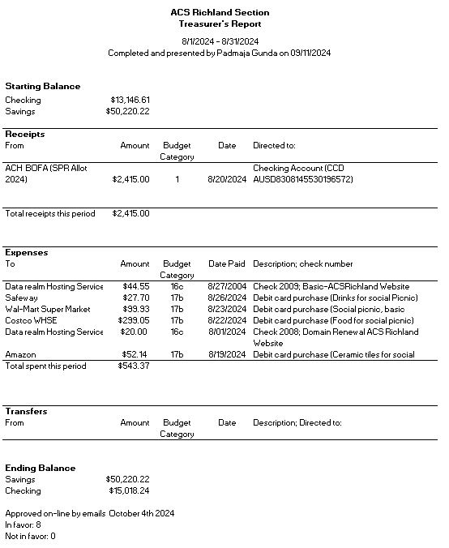

Upcoming events

- October 12th, 2024: Visit of the Science Coyote Canyon Mammoth site – McBones Research Center Foundation.
- October 22nd, 2024: Science Café at the Richland Public Library (5 pm). The speaker is Dr Frankie Wood-Black, and the topic is “Perceptions of Risks”.
- November 8th, 2024: Visit of Lamb Weston facility.
- November 8th, 2024: Social Annual Dinner.
- February 22nd, 2025: Country Mercantile Chocolate Factory tour – The chemistry of Chocolate.

- March 8th, 2025: Visit of LIGO – Laser Interferometer Gravitational-Wave Observatory.
- March 2025: Visit of Wheat Head Brewing – Chemistry behind the making of Beer

