8/14/2024
Call to order: 6:05 pm

Attendance: Sonia Alcantar Anguiano, Shirmir Branch, Janet Bryant, Anna Cavinato, Colby Heideman Jared Kroll, Deepika Malhotra, Dinpajooh Mohammadhasan, Mariefel Olarte.

- Approve July 2024 Meeting Minutes – Shirmir presents the July 2024 executive committee (EC) meeting minutes on behalf of Vanessa. Janet moves to approve the July 2024 EC minutes as presented. Deepika seconds the motion. Motion passes unanimously. Vanessa has the action to upload the July 2024 EC meeting minutes to the Local Section (LS) website.
- Approve July 2024 Treasurer’s Report – Shirmir presents the July 2024 treasurer’s report. Starting balance is $50,220.22 in savings account and $11,466.61 in checking account. The total of receipts for July 2024 is equal to $2,000.00. The total of the expenses for July 2024 is equal to $300.00 as detailed in the attached report. Ending balance is $50,220.22 in savings and $13,146.61 in checking. Treasurer report was approved on-line October 4th with 8 in favor and 0 not in favor.
- LSAC Webinar: 17 July 2024 – Shirmir indicates that she attended the Local Section Activities Committee (LSAC) webinar, but she did not need to present. She indicates that the presentation from New York local section was particularly interesting as they shared that they plan their activities 2 to 3 years ahead of time which allows them to be very responsive when grant opportunities arise. The webinar recording is available from the LSAC website.
- ACS ChemLuminary: 20 August 2024 – Shirmir reminds meeting attendees that the section is finalist for 4 ChemLuminary award including Fostering Interactions between Local Sections and Students Chapters, Outstanding NCW Event for a Specific Audience, Outstanding Public Outreach Event Organized by a Student Group, Outstanding Performance by a Local Section. Shirmir put together a poster regarding the awards for which the section is finalist and Anna will print and present the poster on behalf of the section. Anna will attend the ACS counselor meeting on August 21st. She indicates that there will be a petition to decide whether new ACS zones outside of the United States should be added since 20% of the ACS members reside abroad. This would entail addition of new counselors who reside in these zones. Janet indicates that counselor will also be asked to vote on the dissolution of the India big Chapter and separate this big Chapter into several regional Chapters located across India.
- Summer Picnic: 24 August 2024 – Sonia indicates that she needs 1 or 2 volunteers to help clean up the shelter floor, prepare the food and set up the tables. She proposes to purchase tiles and use paint leftover from the pottery event to have an activity for the children. Sonia is asking if it is possible to purchase a cooler and grilling materials for this event and future ones. The section supports the purchases. Shirmir indicates the budget was already approved for this event and we do not need to vote on it.
- National Chemistry Week: 20 October 2024 – Anna indicates that the theme for the National Chemistry Week is about photography and imaging and the title is “Picture Perfect Chemistry”. Anna can order supplies if people need some booklets or other supplies for events during that week. Shirmir would like to hold a science café about imaging in the medical field during that week and is asking if people have connections in the medical field.
- ACS Program in a Box: 23 October 2024 – Shirmir is interested in participating to ACS Program in a Box. Mariefel indicates that in the past the section was participating with college students, and it may be a good idea to contact Padmaja from CBC. She will reach out to CBC to determine whether they are interested in participating or not.
- DEIR Speaker Series – Anna would like to hold a series of DEIR science café and is asking people from PNNL if they could help her make some connections to identify young speakers. Mariefel can help Anna make some connections at PNNL.
- DEIR Grant Proposal – Shirmir was able to connect with John Cox and she will meet with him at Novel Coffee in Richland this coming Sunday (August 18th) at 11 am. Shirmir indicates that anyone interested in joining this meeting is welcome.
- Safety Science Café: 22 October 2024 – Jared is organizing a science café October 22nd at 5 pm at the Richland Public Library. Dr. Frankie Wood-Black from Northern Oklahoma College will be the speaker and the topic is “Perceptions of Risks”.
- 2025 Elections for the LS Executive Committee – Shirmir reminds everyone that elections are coming soon and the opened positions for next year are Secretary, Treasurer, and co-Chair.
- Students Chapter Activities – no update.
- Committee Reports –
  - Awards – Janet reminds everyone that ACS award nominations are opened, and the deadline is November 1st. She encourages everyone to think of potential nominees.
  - Diversity and Inclusion – see bullets 8 and 9.
  - Education – no update.
  - Government affair – no update.
  - Membership – Anna indicates that there are 5 new members and Sandy sent them welcoming letters.
  - Nominations – see bullet 11.
  - Programs – Sonia contacted Professor Hendon to inquire about the possibility for him to give a talk at the next LS social event. He will decide by the end of September.
  - Public relations – The August Newsletter was sent to the members.
  - Women Chemists – Shirmir indicates that WC is offering grants to entities who have hosted a WC event. Mickey is planning to write a report regarding the April 6th WCC luncheon, and she will apply for the award.
  - Environmental – no update.
  - Safety – See bullet 10.
  - Historian – no update.
Shirmir adjourns the August 2024 executive committee meeting at 7:08 pm.

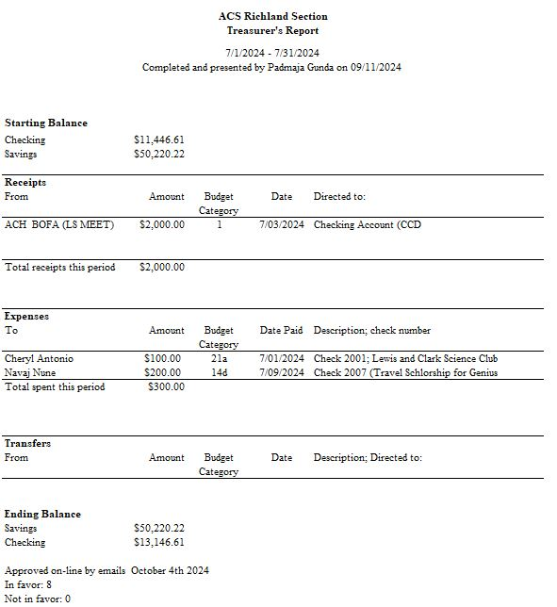

Upcoming events

- August 24th, 2024: Summer Picnic at Badger Mountain Park (starts at 1pm).
- October 12th, 2024: Visit of the Science Coyote Canyon Mammoth site – McBones Research Center Foundation
- October 22nd, 2024: Science Café at the Richland Public Library (5 pm). The speaker is Dr Frankie Wood-Black, and the topic is “Perceptions of Risks”.
- November 8th, 2024: Visit of Lamb Weston facility.
- February 22nd, 2025: Country Mercantile Chocolate Factory tour – The chemistry of Chocolate.

- March 8th, 2025: Visit of LIGO – Laser Interferometer Gravitational-Wave Observatory.
- March 2025: Visit of Wheat Head Brewing – Chemistry behind the making of Beer

