7/10/2024
Call to order: 6:03 pm

Attendance: Sonia Alcantar Anguiano, Shirmir Branch, Janet Bryant, Vanessa Dagle, Sandra (Sandy) Fiskum, Padmaja Gunda, Steven (Steve) Krogsrud, Jared Kroll, Deepika Malhotra, Dinpajooh Mohammadhasan, Mickey Roger.
- Approve June 2024 Meeting Minutes – Vanessa presents the June 2024 executive committee (EC) meeting minutes. Sandy moves to approve the June 2024 EC minutes as presented. Padmaja seconds the motion. Vanessa has the action to upload the June 2024 EC meeting minutes to the Local Section (LS) website.
- Approve June 2024 Treasurer’s Report – Padmaja presents the June 2024 treasurer’s report. Starting balance is $50,181.80 in savings account and $12,511.52 in checking account. The total of receipts for June 2024 is equal to $0.00. The total of the expenses for June 2024 is equal to $1,064.91 as detailed in the attached report. Ending balance is $50.181.80 in savings and $11,446.61 in checking. Sandy moves to approve the June 2024 treasurer’s report as amended. Janet seconds the motion. Motion passes unanimously.
- June Science Café – Kabrena Rodda gave a lecture at the Science Café on June 18th at the Richland Public Library. Although only few people were in attendance, the event went well and was very well received. For the next Science Café, the LS will plan on expanding the advertisement and open the Science Café to the general public. Sandy suggests sending a notification to the Tri-City Herald for the next Science Café to expand advertisement by reaching out to the local community.
- ACS NORM Summary – Shirmir attended the NORM meeting that was held in Pullman. She indicates that she met Professor Melvin Roberts from Walla Walla University who expressed interest in collaborating with the local section to help boost their Student Chapter. Janet and Jared also attended the meeting and gave oral presentations. Shirmir indicates that Dr. Despina won the E. Ann Nalley award.
- LSAC Webinar: 17 July 2024 – The LS was asked to give a 5-minute overview presentation by ACS for the LSAC webinar. Janet recommends giving an overview of the 2023 LS meet grant activities as opposed to the 2023 IPG grant activities to highlight opportunities for grants that are perhaps less known. Shirmir agrees and she will give an overview of activities conducted with the 2023 LS meet grant. Sonia who led the 2023 LS meet grant will provide slides to Shirmir.
- ACS ChemLuminary: 20 August 2024 – Shirmir reminds meeting attendees that the section is finalist for 4 ChemLuminary award including Fostering Interactions between Local Sections and Students Chapters, Outstanding NCW Event for a Specific Audience, Outstanding Public Outreach Event Organized by a Student Group, Outstanding Performance by a Local Section. Shirmir will put together a poster regarding the awards for which the section is finalist and Anna will present the poster on behalf of the section.
- Summer Picnic: 24 August 2024 – Mickey indicates that Sonia reserved a shelter at Badger Mountain Park for August 24th at 1 pm. Shirmir will send an invitation to different societies and Mickey will send an invitation to the PNNL POGO group. The section will provide meats, cutlery, and drinks. It will be potluck style and people can bring shareables. This is a family and dog friendly event. Deepika suggests having activities for children. Sandy recommends that some folks come early to clean up the shelter.
- DEIR Grant Proposal – Shirmir has engaged with John Cox to hold an event at the Umatilla reservation for next year grant. She indicates that anyone with ideas for DEIR activities should reach out to her and Sonia.
- Students Chapter Activities – no update.
- Committee Reports –
  - Awards – Janet reminds everyone that nominations for ACS national awards will open November 1st.
  - Diversity and Inclusion – no update.
  - Education – no update.
  - Government affair – no update.
  - Membership – Sandy indicates that there are 2 new members, 367-chapter members, 228 community associates, 1 transfer in, 16 terminations.
  - Nominations – no update.
  - Programs – Sonia is looking for a Science Café speaker and she is asking attendees to reach out to her if they have any ideas for potential speakers.
  - Public relations – Steve still needs information for the August Newsletter from the members who organized events. He will feature the Summer Picnic event in the Newsletter. Steve needs inputs by the end of July.
  - Women Chemists – Mickey is thinking of a WCC focused Science Café.
  - Environmental – no update.
  - Safety – Jared indicates that Dr. Frankie Wood-Black from Northern Oklahoma College will be a speaker for a future Science Café, and he will meet with her to discuss details.
  - Historian – no update.
Shirmir adjourns the July 2024 executive committee meeting at 7:09 pm.
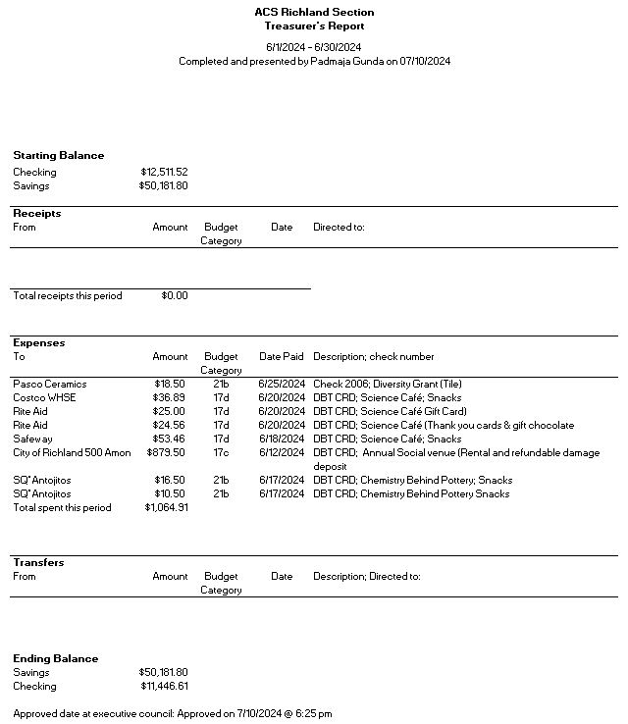

Upcoming events

- August 24th: Summer Picnic at Badger Mountain Park (starts at 1pm).

