4/10/2024

Call to order: 6:03 pm

**Attendance**: Sonia Alcantar Anguiano, Shirmir Branch, Anna Cavinato, Vanessa Dagle, Sandra (Sandy) Fiskum, Padmaja Gunda, Colby Heideman, David (Dave) Heldebrant, Steven (Steve) Krogsrud, Mariefel Olarte, Deepika Malhotra, Mikey Rogers.

1. **Approve February and March 2024 Meeting Minutes** – Vanessa presents the February and March 2024 executive committee (EC) meeting minutes. Anna moves to approve the February and March 2024 EC meeting minutes. Deepika seconds the motion. Motion passes unanimously. Vanessa has the action to upload the February and March 2024 EC meeting minutes to the Local Section (LS) website.
2. **Approve March 2024 Treasurer’s Report** – Padmaja presents the March 2024 treasurer’s report. Starting balance is $58,138.41 in savings account and $5,675.73 in checking account. The total of receipts for March 2024 is equal to $43.39. The total of the expenses for March 2024 is equal to $1,150.00 as detailed in the attached report. Ending balance is $58,181.80 in savings and $4,525.73 in checking. Sandy moves to approve the March 2024 treasurer’s report. Anna seconds the motion. Motion passes unanimously.
3. **WCC Luncheon** – Shirmir indicates that the WCC networking Luncheon was help on April 6th at Budd’s Broiler. 12 people attended the event and early career were given the opportunity to exchange with more senior scientists.
4. **ACS Spring Meeting Report** – Anna provides a summary of the ACS Spring meeting. She indicates that 2 individuals, Rigoberto Hernandez and Laura Sremaniak, were selected as candidates for the 2025 President-Elect. These 2 candidates will join Mukund Chorghade who is a petition candidate. Anna reminds everyone that the preference forms to be on any ACS national Committee opened on March 1st and will close on July 1st.
5. **Earth Day Activities** – This year Earth Day theme is “Get a charge out of chemistry – batteries”. Shirmir indicates that ACS will hold a booth at the Earth Day event on April 20th from 12 pm to 4 pm and volunteers are needed to conduct battery demonstrations with the children. Shirmir and Dave will also serve as moderators for the Ted talk session. Colby indicates that EOU will hold an event at the library doing 3-4 activities related to batteries.
6. **MEET Grant Events** – Sonia indicates that there are 2 activities left for the LS-MEET grant. Wheat Head Brewery in Kennewick will give a tour of their facility explaining the science behind the making of beer. This will be followed by a tasting of their beer. A planetarium show is also scheduled for April 27th and the show will start at 11:30 am. Snacks will be provided for both events.
7. **DEIR Grant Events** – Sonia met with the principal of Marie Curie Elementary school to hold a pottery event. The event is scheduled for April 24th from 4 pm to 6 pm. Sonia asks for people who can volunteer to contact her. The school has asked if the local section can provide snacks or prizes for the students. Sonia is requesting $200.00 for prizes. There is no need to approve the $200.00 because it is already budgeted in the Diversity Affairs Committee section of the 2024 budget.
8. **Travel Request** – Navaj Nune a student from Hanford is requesting support to attend the Genius Olympiad occurring in Rochester, NY. Shirmir will follow up with him to request a budget from him. Sonia reminds everyone that we should open it to other students in the future for equity purpose. Colby will work on getting a process put together.
9. **Student Chapter Activities** – Colby report on the students’ trip to ACS. The EOU students participated to the ChemDemo Exchange. They attended the award ceremony where they received an outstanding award. They also presented posters at the Sci-Mix event.
10. **Chemistry Olympiad** – Padmaja indicates that 3 students (2 from Hanford and 1 from Moses Lake) were selected for the National Chemistry Olympiad. It will be held at Columbia Basin College on April 14th. Padmaja will order pizza for the students’ lunch since they will be spending the day taking the exam.
11. **Committee Reports** –
    1. Awards – Janet and Shirmir work together to nominate Kabrina Rodda as ACS fellow Janet also nominated Niraj Kumar for an ACS fellow. Ram was nominated for the E. Ann Nalley Northwest Region award for Volunteer Service to the American Chemical Society.
    2. Diversity and Inclusion – see bullet 7.
    3. Education – see bullets 5 and 9.
    4. Government affair – no update.
    5. Membership – Sandy indicates that 3 new members have joined the local section which brings the total number of members to 367.
    6. Nominations – no update.
    7. Programs – no update.
    8. Public relations – no update.
    9. Women Chemists – see bullet 3.
    10. Environmental – no update.
    11. Safety – Jared is looking at organizing a science café.
    12. Historian – no update.

Shirmir adjourns the April 2024 executive committee meeting at 7:07 pm.

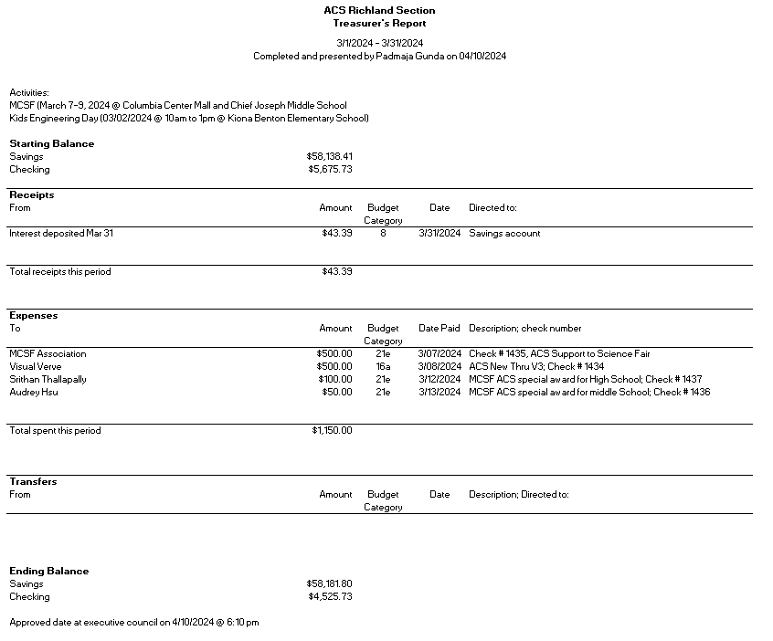

**Upcoming events**

* None scheduled yet.