3/13/2024

Call to order: 6:06 pm

**Attendance**: Shirmir Branch, Janet Bryant, Anna Cavinato, Sandra (Sandy) Fiskum, Padmaja Gunda, Colby Heideman, David (Dave) Heldebrant, Steven (Steve) Krogsrud, Deepika Malhotra, Mikey Rogers.

1. **Approve February 2024 Meeting Minutes** – Vanessa is unable to attend the meeting and the EC minutes for February will be presented during the April meeting.
2. **Approve February 2024 Treasurer’s Report** – Padmaja presents the February 2024 treasurer’s report. Starting balance is $58,138.41 in savings account and $6,014.25 in checking account. The total of receipts for February 2024 is equal to $500.00. The total of the expenses for February 2024 is equal to $838.52 as detailed in the attached report. Ending balance is $58,138.41 in savings and $5,657.73 in checking. Sandy moves to approve the February 2024 treasurer’s report as amended. Deepika seconds the motion. Motion passes unanimously.
3. **Mid-Columbia Science Fair: March 7th-9th** –Dave indicates that the event was well attended. A total of 86 judges including 10 judges for the LS section were in attendance. The LS awarded one student from middle school and one student from high school.
4. **Support for Local Elementary Science Club**: Lewis and Clark elementary school reached out to Dave and requested support from the LS to purchase materials for the science activities that the school has been holding every Friday for the past seven years. Dave asks if the LS can award $100.00 to the school for purchasing the needed materials. Sandy moves to approve the motion and grant $100.00 to the science club. Deepika seconds the motion.
5. **Previous events Summaries** – Padmaja indicates that the Chemistry Olympiad was held March 2nd and only 2 students out of the 7 expected students attended. Padmaja offered the missing students to attend the next week, but they were still unavailable. Examination was done and the results were uploaded on-line. The LS organized a planetarium visit at CBC on February 17th and another visit is planned for the month of April. The LS participated to Introduce a Girl to Engineering event organized by the Society of Women Engineers and held at the Richland Public Library. The local section did a “Cloud in a Bottle” demonstration and about 100 students attended this event. The LS also participated to Kids Engineering Day organized by the Women in Nuclear held at Kiona Benton Elementary School and about 200 students were in attendance. The LS held a booth and conducted the “Cloud in a Bottle” demonstration.
6. **WCC Luncheon** – Mikey is organizing a “Women’s Networking Brunch with ACS” April 6th from 11 am to 1 pm at Budd’s Broiler. Mikey is planning for a total of about 30 people and if more people register an email will be sent to the EC committee to approve additional funding. Some activities will be held, and some food will be served.
7. **Brewery Tour** – As part of the LS MEET grant, Sonia is organizing a brewery guided tour April 13th at Wheat Head Brewing. The tour will be held at 10 am and it will be followed by a tasting activity at 11 am. Sonia is requesting $100.00 for purchasing non-alcoholic drinks. Anna indicates that there is no need to pass a motion since it is already itemized in the 2024 budget.
8. **Earth Day Events** –The Earth Day at the Reach Museum will be held April 20th from 12 pm to 4 pm. The section will present an activity table and it will participate to the Tri-talks speaker’s event. Anna is also holding an event for Earth Day on April 22nd at La Grande Public Library. Anna indicates that it would be good to purchase some “Chemists Celebrate Earth week” booklets and perhaps other items for both Earth Day events.
9. **Students Chapter Activities** – Anna indicates that 11 students from EOU will attend the ACS meeting in New Orleans. They will present posters and attend several events including the Sci-Mix and the outstanding award ceremony. Colby indicates that more activities will be held in elementary schools and at the senior center in the coming months. Padmaja indicates that CBC was invited to participate to science events at Lewis and Clark and at Badger Mountain elementary schools.
10. **ACS Fellow Nominations** – Janet is working on documentation to nominate Kabrena Rodda as an ACS fellow.
11. **Committee Reports** –
    1. Awards – no update
    2. Diversity and Inclusion – see bullet 8.
    3. Education – no update.
    4. Government affair – no update.
    5. Membership – no update
    6. Nominations – no update
    7. Programs – see bullet 7.
    8. Public relations – no update
    9. Women Chemists – see bullet 6.
    10. Environmental – no update
    11. Safety – no update
    12. Historian – no update

Shirmir adjourns the March 2024 executive committee meeting at 6:58 pm.

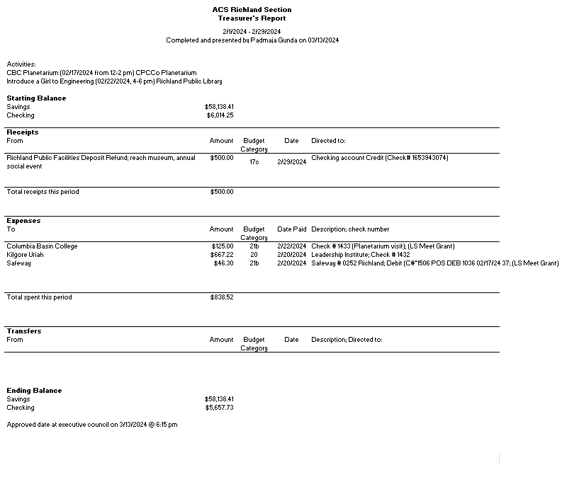

**Upcoming events**

* Women Chemists Luncheon: April 6th at Bud’s broiler
* Brewery Tour: April 13th at Wheat Head Brewing from 10 am to 12 pm
* Earth Day Reach Museum: April 20th from 12 pm to 4 pm
* Earth Day La Grande Public Library: April 22nd
* Planetarium visit: April 27th from 11 am to 1 pm