2/21/2024

Call to order: 6:01 pm

**Attendance**: Shirmir Branch, Anna Cavinato, Vanessa Dagle, Sandra (Sandy) Fiskum, Padmaja Gunda, Colby Heideman, Steven (Steve) Krogsrud, David (Dave) Heldebrant, Uriah Kilgore, Jared Kroll, Mikey Rogers.

1. **Approve January 2024 Meeting Minutes** – Vanessa presents the January 2024 executive committee (EC) meeting minutes. Dave moves to approve the January 2024 EC meeting minutes with change of format as amended with clarifications. Anna seconds the motion. Motion passes unanimously. Vanessa has the action to upload the January 2024 EC meeting minutes to the Local Section (LS) website.
2. **Approve January 2024 Treasurer’s Report** – Padmaja presents the January 2024 treasurer’s report. Starting balance is $58,138.41 in savings account and $1,376.72 in checking account. The total of receipts for January 2024 is equal to $5,286.53. The total of the expenses for January 2024 is equal to $649.00 as detailed in the attached report. Ending balance is $58,138.41 in savings and $6,014.25 in checking. Sandy moves to approve the January 2024 treasurer’s report as presented. Colby seconds the motion. Motion passes unanimously.
3. **Chemistry Olympiad** –Padmaja indicate that the Chemistry Olympiad will be held at CBRC on March 2nd. Padmaja expects that at least 7 students will compete for this event. She does not need help at this time.
4. **EOU Request For Financial Support To Attend The ACS Spring Meeting** –Anna introduces 2 students Gabriel Streblow (vice president of the chemistry club) and Elizabeth Zamora (secretary of the chemistry club) from EOU who are planning to attend the ACS spring meeting in New Orleans March 15-19. Gabriel indicates that they are 11 students from EOU who will attend the ACS meeting and present a total of 6 posters. They are looking for financial support for a total of $2,858.12 and are asking if the Richland local section would be willing to support them. Dave recommends that the Richland local section fully support the students. Sandy moves to approve the financial support to EOU students for a total of $2,858.12. Dave seconds the motion. Motion passes unanimously.
5. **2023 Annual Report** – Shirmir indicates that the report was submitted in time. It includes 7 ChemLuminary nominations for Fostering Interactions between Locals Sections and Student Chapters, Most Creative NCW Celebration, Outstanding NCW event for a Specific Audience, Investigators of Science, Public Outreach Event organized by Student Group, Best Overall Local Section Minority Affairs and Best Activity or Program stimulating Member involvement.
6. **Mid-Columbia Science Fair: March 7th** –Dave indicates that judges are needed for the Mid-Columbia Science Fair and if someone is interested, they should contact him. Dave is also looking for specific judges to represent the Richland LS that will judge chemistry posters from middle and high school students. Two awards will be given by the LS, one for a middle school student and one for a high school student. This event will be held at the Columbia Mall in Kennewick, and it will officially start at 8:30 am. Anna has the action to send an email to the ACS members to put a request for judges.
7. **Introduce a Girl to Engineering Day: Feb 22st** – Shirmir indicates that the LS will participate to the “Introduce a Girl to Engineering Day” event organized by the Society of Women Engineers. The section will have a booth and do a Cloud in the bottle activity. There are 4 volunteers total and that should be sufficient, but anyone wants to volunteer should contact Shirmir. It will be held February 22nd at the Richland Public Library from 4 pm to 6pm.
8. **Grant Activities: MEET/DEIR** – Shirmir indicates that for the MEET grant, the LS section organized a visit at the Planetarium February 1st. There were about 12 attendees. The next Planetarium visit will be April 27th from 11 am to 1 pm. For the DEIR grant, Shirmir is planning to meet with one off the principals of the Pasco middle schools.
9. **ACS Leadership Institute** – Uriah indicates that he attended the ACS Leadership Institute event that was held January 26th-28th in Atlanta. Uriah indicates that he was part of the Leadership Track and that he had the opportunity to learn more about the different grants that ACS offers. Anna indicates that she also attended the event, and she presented a poster for the LS section. Mickey indicates that it was her first time going and she really enjoyed participating to the Younger Chemist Track.
10. **Outreach Activities** – Shirmir indicates that the section was invited to participate to the “Kids Engineering Day” held by Women in Nuclear on March 2nd at Kiona Benton city Elementary. Anyone interested in organizing or participating should contact Shirmir. The LS has been invited to participate to the earth day event at the Reach Museum April 20th. Mickey is looking for volunteers to moderate and facilitate Ted talks type presentations. Anna offers to order ACS booklets for earth day week and ship them to Richland. As part of the MEET grant, Sonia is communicating with a local brewery to hold an event there. Mickey is planning a Women Chemists brunch April 6th at Bud’s broiler.
11. **Students Chapter Activities** – In addition to attending the ACS spring in New Orleans Anna, and the students from EOU will conduct activities in two fifth grade classroom on February 29th.
12. **Committee Reports** –
    1. Awards – no update
    2. Diversity and Inclusion – see bullet 8.
    3. Education – no update.
    4. Government affair – no update.
    5. Membership – Sandy sent 5 welcoming letters to new members. There are 3 transfers and 1 termination.
    6. Nominations – no update
    7. Programs – see bullet 10.
    8. Public relations – no update
    9. Women Chemists – see bullet 10.
    10. Environmental – no update
    11. Safety – no update
    12. Historian – no update
13. **Round Table** – Sandy suggests sending Matt Monroe the list of the upcoming events so that he can add them to the website. Sandy also suggests having a common meeting with another society. Dave indicates that Lewis and Clark will put a request to obtain more chemicals and materials to continue the science event they have been doing every Friday for the past seven years. A mechanism needs to be put in place for the teacher award.

Anna moves to adjourn the February 2024 executive committee meeting. Sandy seconds the motion.

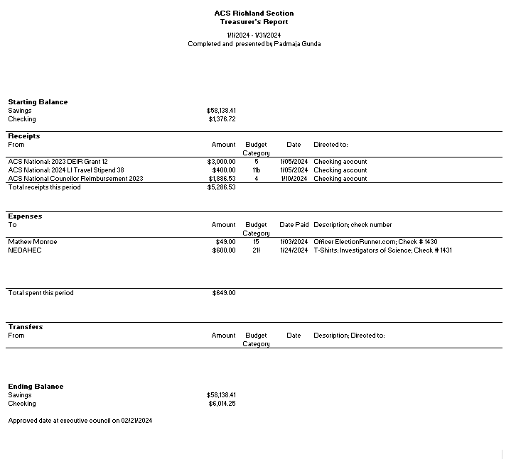

**Upcoming events**

* Women Chemists Luncheon: April 6th at Bud’s broiler
* Earth Day Reach Museum: April 20th from 12 pm to 4 pm
* Planetarium visit: April 27th from 11 pm to 1 pm