1/10/2024
Call to order: 6:03 pm

Attendance: Shirmir Branch, Anna Cavinato, Vanessa Dagle, Sandra (Sandy) Fiskum, Padmaja Gunda, Colby Heideman, Steven (Steve) Krogsrud, David (Dave) Heldebrant, Uriah Kilgore, Jared Kroll, Deepika Malhotra, Mariefel Olarte, Mikey Rogers.

- Approve December 2023 Meeting Minutes – Vanessa presents the December 2023 executive committee (EC) meeting minutes. Sandy moves to approve the December 2023 EC meeting minutes with change of format as amended with clarifications. Deepika seconds the motion. Motion passes unanimously. Vanessa has the action to upload the December 2023 EC meeting minutes to the Local Section (LS) website.
- Approve December 2023 Treasurer’s Report – Padmaja presents the December 2023 treasurer’s report. Starting balance is $55,000 in savings account and $4,775.64 in checking account. The total of receipts for December 2023 is equal to $638.41. The total of the expenses for December 2023 is equal to $898.92 as detailed in the attached report. A total of $3,094.00 was transferred from the checking account to the savings account. Ending balance is $58,138.41 in savings and $1,376.72 in checking. Sandy moves to approve the December 2023 treasurer’s report as presented. Anna seconds the motion. Motion passes unanimously.
- 2024 LS 2024 Budget/ Membership Meeting – Steve indicates that the LC budget does not need to be approved by the LS members since the bylaws have changed and only the executive committee is required to approve the budget. The LS 2024 budget was approved by the executive committee in December 2023. Shirmir asks if we should have a membership meeting using a hybrid format every quarter. The executive committee agrees. Shirmir will plan for a membership meeting in March at the Richland Library.
- 2023 Annual Report – Deepika presents a form to fill out for those who organized events in 2023 to help collect information to write the annual report. Deepika asks to receive the information by February 10th.
- Newsletter – Steve is working on the February Newsletter, and he asks to get inputs (before the end of January) from those who organized events during the last quarter of 2023. Sandy suggests that Padmaja looks at the first Newsletter from last year to see how the budget was presented in last year Newsletter.
- Grant Activities – Shirmir indicates that Sonia’s proposal for a DEI grant was awarded, and she will get in touch with Sonia to get more information regarding the pottery event. Shirmir will work on the IPG proposal this weekend. The proposed idea for the IPG grant is a series of seminars at Eric Hoppe’s winery.
- ACS Leadership Institute – Uriah has agreed to attend the event on behalf of the Richland LS. Anna will print the poster and bring it to the event.
- Outreach Activities – Invitation Shirmir received an invitation from the Society of Women in Engineering to join them for their girls in engineering day to be held at the Richland Public Library on February 22nd from 4 pm to 6 pm. Shirmir indicates that the LS was also invited to participate to a kids’ engineering event held at Kiona Benton City elementary school. Anyone interested to participate on behalf of the LS should contact Shirmir. Dave is looking for people to act as judges for the Mid-Columbia Science Fair to be held on March 7th. Anyone interested to help can reach out to Dave. Mickey is leading an earth day event at the Reach Museum to be held on April. The theme of the ACS 2024 Earth Day is “CCEW 2024 Get a Charge Out of Chemistry”. She is asking if some members of the LS could host some Ted Talks type speech/ presentations.
- Student Chapter Activities – Anna indicates that she has 9 students attending the ACS spring meeting in New Orleans and she will write a request letter to the LS for some support.
- Committee Reports – Shirmir is still looking for a chair for the Women Chemists committee and the Public relations committee. Deepika as the past chair will be the new Awards and Nominations chair. Anna will continue to be the chair for Diversity and Inclusion. Kristen has tentatively agreed to be the Government affair chair. Sandy will continue to be the Membership chair. Shirmir will ask Sonia to be the Programs chair since she is the new chair elect. Uriah will continue to be the chair for the Environmental Improvement committee. Jared will continue to be the chair for the Safety committee. Mickey will be the chair for the Young Chemists committee.
  - Awards – no update
  - Diversity and Inclusion – no update
  - Education – no update.
  - Government affair – no update.
  - Membership – no update
  - Nominations – no update
  - Programs – no update
  - Public relations – no update
  - Women Chemists – no update
  - Environmental – no update
  - Safety – no update

Anna moves to adjourn the January 2024 executive committee meeting. Deepika seconds the motion.
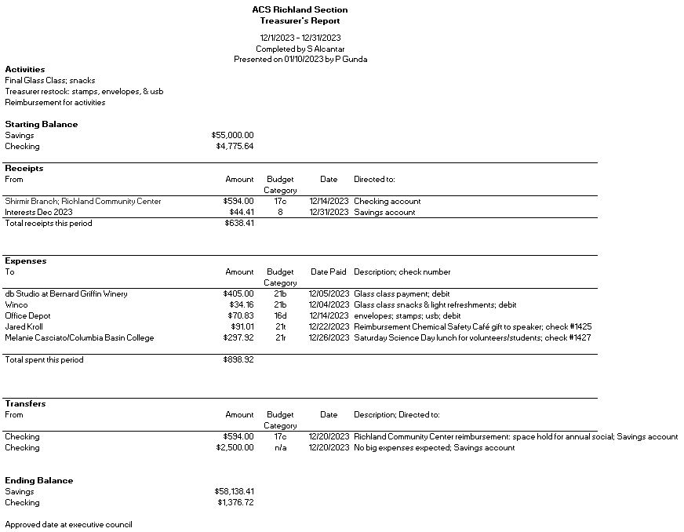

Upcoming events

- Planetarium visit: February 17th from 12 pm to 2 pm
- Planetarium visit: April 20th from 12 pm to 2 pm
- Pottery event - date TBD

